Day 11:
1)Actuators:
Spring Boot Actuator is a sub-project of the Spring Boot framework that provides production-ready features to help you monitor, manage, and audit your application. It exposes various operational data—like health status, metrics, and thread dumps—via HTTP REST endpoints.

2)Advantages:
- Real Time Monitoring – Track JVM Performance, memory usage.
- Zero-Code setup - Access the metrics by adding dependency itself.
- Infrastructure Ready-Integrates with external monitoring tools like Grafana ,Data dog etc..

3)Actuator Endpoints:
/actuator/health – Show basic application up/down health statuses.
/actuator/metrics – Exposes OS,JVM and application level metrics.
/actuator/env -Returns current environment properties and variables.
/actuator/beans-Display a complete list of all registered Spring beans.
/actuator/loggers – Lets you view and dynamically change the log levels.
/actuator/threaddump-For diagnosing thread deadlocks.

5)Spring security architecture defines the component and workflow used to authenticate and authorize access to the application.

6) Components of Spring Security Architecture:
Filter Chain : Acts as the entry point for all incoming request.Every request passes through the chain of filters such as usernameAuthenticationFilter , Basic Authentication Filter etc..
Authentication Manager:
Core component for handling user authentication. Delegates the request to the corresponding authentication provider.
Authentication Providers: Components responsible for authenticating user credentials.
Eg-JWT Authentication provider, OAuth Authentication provider.

usersDetail Service:
Loads user specific data from the data source. Return a Userdetails object.

Password Encoder:
Ensure secure password storage and validation.
Securitycontextholder:
Stores the security context for the current request and threads.
Principle – Logged In user
Authorities – Roles and access.

7)Spring Security Architecture:
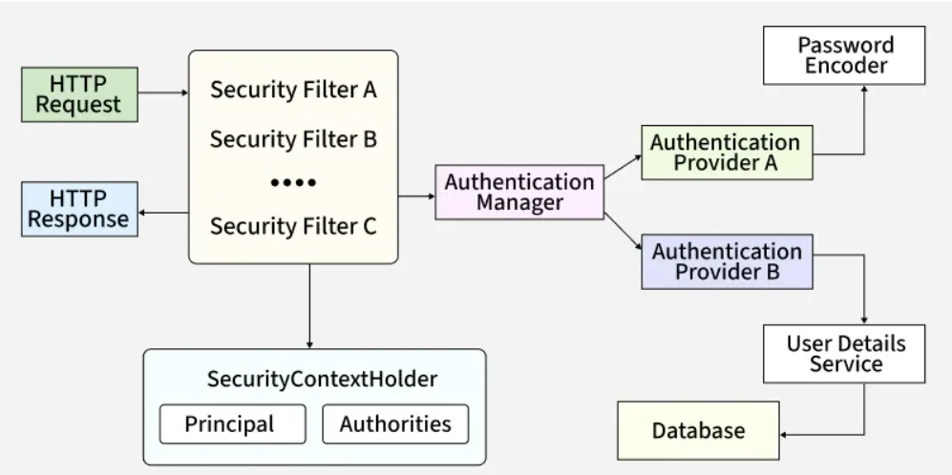

8) Security Filter chain:
Request hitting the application will pass through the series of filters that have different function.

Example Code:
import org.springframework.context.annotation.Bean;
import org.springframework.context.annotation.Configuration;
import org.springframework.security.config.Customizer;
import org.springframework.security.config.annotation.web.builders.HttpSecurity;
import org.springframework.security.config.annotation.web.configuration.EnableWebSecurity;
import org.springframework.security.config.http.SessionCreationPolicy;
import org.springframework.security.core.userdetails.User;
import org.springframework.security.core.userdetails.UserDetails;
import org.springframework.security.core.userdetails.UserDetailsService;
import org.springframework.security.crypto.bcrypt.BCryptPasswordEncoder;
import org.springframework.security.crypto.password.PasswordEncoder;
import org.springframework.security.provisioning.InMemoryUserDetailsManager;
import org.springframework.security.web.SecurityFilterChain;

@Configuration
@EnableWebSecurity
//by adding this annotation we are telling springboot that we want to we want to configure this SpringSecurityFilterChain
public class WebSecurityConfig { //create a configuration class

@Bean
SecurityFilterChain securityFilterChain(HttpSecurity httpSecurity) throws Exception {
httpSecurity
.authorizeHttpRequests(auth->
auth
.requestMatchers("/<anyEndPoint>/**").permitAll() // give any of your 'get' request endpoint
.anyRequest().authenticated()) // All other requests require authentication

.csrf(csrfConfig-> // Disable CSRF for simplicity, not recommended for production
csrfConfig
.disable())

.sessionManagement(sessionConfig -> // Disable JSESSIONID for simplicity, not recommended for production
sessionConfig
.sessionCreationPolicy(SessionCreationPolicy.STATELESS))

.formLogin(Customizer.withDefaults()) // Enable form login here I use default login

.logout(Customizer.withDefaults()); // Enable logout

return httpSecurity.build(); //when you add build this throws an exception
}

// Custom Authentication Providers
@Bean
UserDetailsService myInMemoryUserDetailsService(){

UserDetails user = User //for user role
.withUsername("<UserName>") // Replace <UserName> with the actual username
.password(passwordEncoder().encode("<UserPassword>")) // Replace <UserPassword> with the actual password
.roles("USER")
.build();

UserDetails admin = User //for admin role
.withUsername("<AdminName>") // Replace <AdminName> with the actual username
.password(passwordEncoder().encode("<AdminPassword>")) // Replace <AdminPassword> with the actual password
.roles("ADMIN")
.build();

return new InMemoryUserDetailsManager(user,admin);

}

// Password Encoding
@Bean
PasswordEncoder passwordEncoder(){
return new BCryptPasswordEncoder();
}
}

9)Authentication Manager:
It is a core interface that spring security uses for the authentication process. It has only one method authenticate which when implemented in a class that implements an Authentication Manager has all the logic for authenticating a user request.

public class CustomAuthenticationManager implements AuthenticationManager {

@Autowired
UserRepo userRepo;

@Autowired
PasswordEncoder passwordEncoder;

@Override
public Authentication authenticate(Authentication authentication) throws AuthenticationException {
Optional<User> user = userRepo.findByUserName(authentication.getName());
if (user.isPresent()) {
if (passwordEncoder.matches(authentication.getCredentials().toString(), user.get().getPassword())) {
List<GrantedAuthority> grantedAuthorityList = new ArrayList<>();
for (Role role : user.get().getRoleSet()) {
grantedAuthorityList.add(new SimpleGrantedAuthority(role.getName()));
}
return new UsernamePasswordAuthenticationToken(authentication.getPrincipal(), authentication.getCredentials(), grantedAuthorityList);
} else {
throw new BadCredentialsException("Wrong Password");
}
} else {
throw new BadCredentialsException("Wrong UserName");
}
}
}

10) An AuthenticationProvider in Spring Security is a core interface responsible for processing a specific type of authentication request. It contains the actual verification logic (e.g., checking passwords against a database, validating an LDAP account, or decoding a JWT token).
@Component
public class CustomAuthenticationProvider implements AuthenticationProvider {

@Override
public Authentication authenticate(Authentication authentication) throws AuthenticationException {
String username = authentication.getName();
String password = authentication.getCredentials().toString();

// Implement your custom verification logic here (e.g., call external API)
if ("admin".equals(username) && "secret".equals(password)) {
// Return an authenticated token populated with user authorities/roles
return new UsernamePasswordAuthenticationToken(username, password, Collections.emptyList());
} else {
throw new BadCredentialsException("Invalid login credentials.");
}
}

@Override
public boolean supports(Class<?> authentication) {
// Define what token type this provider accepts
return UsernamePasswordAuthenticationToken.class.isAssignableFrom(authentication);
}
}

11)Users Detail Service:
- Loads user-specific data (username, password, roles) from a data source like a database.
- Returns a UserDetails object.
- @Configuration
- public class UserConfig {

- @Bean
- public UserDetailsService userDetailsService(PasswordEncoder encoder) {
- return new InMemoryUserDetailsManager(
- User.withUsername("john")
- .password(encoder.encode("password"))
- .roles("USER")
- .build(),
- User.withUsername("admin")
- .password(encoder.encode("admin123"))
- .roles("ADMIN")
- .build()
- );
- }
- }

12) Ensures secure password storage and validation.
@Configuration
public class PasswordConfig {

@Bean
public PasswordEncoder passwordEncoder() {
return new BCryptPasswordEncoder(); // Strong hashing
}
}

13)Security Context Header:
Stores the SecurityContext for the current request/thread. And holds the Authentication object, which contains Principle and Authorities.
@RestController
public class UserController {

@GetMapping("/me")
public String getCurrentUser() {
Authentication authentication = SecurityContextHolder.getContext().getAuthentication();
return "Logged in as: " + authentication.getName() +
" | Roles: " + authentication.getAuthorities();
}
}

15)Thyme Leaf:
Thymeleaf is a modern, server-side Java template engine used in Spring Boot applications to render dynamic HTML web pages. It acts as the View layer in a traditional Model-View-Controller (MVC) architecture, processing backend Java data and merging it with HTML templates before sending the final page to the user's browser.
- Why it is used?
- Natural Templating.
- Static Prototyping
- Modern Replacement for JSP
- Built in layouts and Utilities
- Auto-Configuration.

17) Advantages of Thyme Leaf:
- Natural Templating
- Seamless Spring boot integration
- High Developer productivity
- Architecture and security.

18)Caching in springboot:
A Cache is any temporary storage location that lies between the application and persistence database or a third-party application that stores the most frequently or recently accessed data so that future requests for that data can be served faster.

19)Features of springboot:
- Microservice architecture
- Auto Configuration
- Reduces boiler plate code
- Have IOC Container
- Embedded servers.

20)Types of caching:
- CDN Caching,
- Database Caching,
- In Memory Caching,
- Web Server Caching.

21)Annotations in caching:
The simplest way to enable caching behavior for a method is to mark it with @Cacheable.
Since the cache is small in size. We don't want to populate the cache with values that we don't need often. Caches can grow quite large, quite fast. We can use the @CacheEvict annotation to remove values so that fresh values can be loaded into the cache again:
@CachePut annotation can update the content of the cache without interfering with the method execution.
@Caching
@Caching is used in the case we want to use multiple annotations of the same type on the same method.

22)@InjectMocks:
The @InjectMocks annotation in Mockito automatically builds an instance of your test class and injects any fields marked with @Mock or @Spy into it using reflection. It saves you from writing manual setup code or long constructor calls

23) The Mockito Spy annotation creates a partial mock of a real object. It delegates calls to actual methods of the real instance by default.

24) The @Mock annotation in frameworks like Mockito creates a fake (mock) object of a class or interface. It helps you test code safely. It stops your code from making real database or network calls during unit tests.
Uses of Mock:
- Isolate test,
- Control behavior,
- Reduce boilerplate code,
- Pair with injection- Works purely with @InjectMocks to pass fake dependencies into your main test project.

25)Partial Mocking:
Partial mocking in Spring Boot allows you to mock specific methods of a class or a Spring bean while keeping the actual implementation for the remaining methods.

26)@verify() – It is used to check a method is called or not.

27)Mock Annotations:

